I used the mounting adaptor to fix the iphone6 of a single camera, took the photo and did the subsequent data processing. In the case of iphone6, because of the mounting adaptor, the light in four directions can all be illuminated onto the chip, so there is no alignment problem in the x and y directions.

In the iPad’s case, the mounting adaptor cannot fix the iPad because of its big size. Therefore, I only can put the iPad on the computer case and take the images. However, the computer case will block the light in one direction. I can only take two photos in the opposite direction light source and then turn the chip to ninety degrees to continue to take two photos under the previous light source. In this case, there is no alignment problem when calculating norm map X and Y, but there will be alignment problems when calculating the height map.

However, the photo taken by iphone6 is much more blurred than the ipad, as shown below.



iPhone6 ipad2018

Although the iPhone will not have alignment problems, the results of the iPhone case are much worse than the results of the iPad case. I think the blurring of the picture causes it.

So I will only show the result of iPad case.

According to the previously derived point source model, it can be seen that maintaining 40cm can substantially reduce the error.

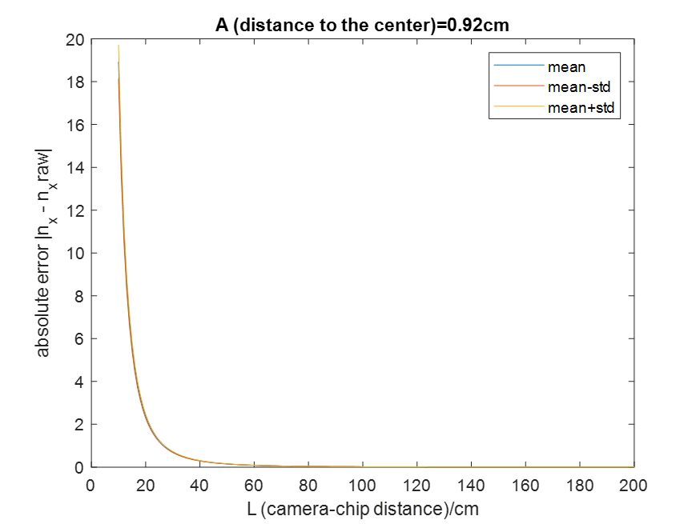

I used a 60W bulb to keep the distance of 40cm from the chip and illuminate the chip at 45 degrees.

****

Aligned images (iPad2018)

Since the brightness of the four photos is different, I need to balance their brightness to calculate the norm map. The following are the histograms of the four images and the Gaussian fitted curve.





I can use the fitted Gaussian curve to get the brightness of each graph and balance them.

After obtaining images of brightness balance, I made a scatter plot of x, y directions for each set of chips



For those points that are far from the diagonal, I guess they are the highlights caused by specular reflection. I replaced these points with the average of the points around these points.



The points on the processed scatter plot are significantly more concentrated near the diagonal

After marking these points on the original image, we can observe that most of these are bright spots on the original image.



Now we can

1. calculate the norm map X and Y
2. calculate the correlation of norm maps in camera and scanner cases
3. reconstruct the height maps and get the subbands of them
4. calculate the correlation of subbands in camera and scanner cases

Result of norm map’s correlation





Result of subbands’ correlation:





Scans 1-4 x Camera 1-3

Conclusion:

1. The correlation of norm map is better than before. The matched cases have significantly higher correlations in the x and y directions than the unmatched cases, except for some cases, but I think the wrong position of the light source is the reason. We can ignore these cases.
2. The high frequency subband of the matching case height map is higher than the unmatched case. Although they are not particularly high, they are still distinguishable.